**Technological Institute of Costa Rica**



**School of Academic Area of Information Technology**

**Administration Bachelor's Degree in Information Technology**

# Administration

**Algorithms and data structures**

**Scheduled Project 2**

**Students:**

Carlos Alonso Hernández Corrales 2022291616

Janys Torres Agüero 2022008183

Jefferson Sanabria Brenes 2022111213

**Professor:**

**Nestor Morales Rodriguez**

**Group 2**

**2nd Semester**

***Description of the problem.***

For this programmed project, the objective of creating an APTEC application must be met that allows managing information on project tasks, allows having information on the tasks necessary to complete the project, its associated resources and the calculation of the critical path, increasing knowledge about hierarchical data structures, general data structure (Graphs and trees), practice experimentation and problem solving, also promoting teamwork and decision making.



***What has to be resolved?***

We must resolve that the APTEC application allows managing project task information, allowing information on the tasks necessary to complete the project, the associated resources and the calculation of the critical path of the project. That it complies with the functionalities of adding and modifying the information of different tasks necessary to complete the project, that it stores an ID, a description, type of task (Operative Task, Approval task, Contract signing, Management task, changes), effort, time and a manager. That manages to register the information of documents associated with a task, allowing the user to access any file related to a task, search any task and file in the system, modify the information of a document except the ID and delete a document, displaying the path of files in the binary search tree. Achieving the creation of the recommended route to finish the project, the user must select the order of tasks to be completed and the system must automatically obtain the effort required to go from each defined source and destination task, the information obtained must be recorded as an edge of the project. graph, for each edge the effort and the estimated time it takes between tasks must be recorded, in addition to displaying the route in the console with all the tasks, thus allowing to store the information of the project resources (ID, name of the resource, resource type, resource capacity, Available quantity, manager). That shows the tasks of the project in the form of a tree from any point in the project, shows the client a recommendation of the order in which they should carry out the selected tasks taking into account the efforts between tasks, using the algorithm of shortest paths (Dijkstra ). Using a console to display the information maintaining the persistence of the data of the saved elements and the integrity before the occurrence of errors.



***How is it going to be done?***

To solve this problem, we create a structure to store the information of the documents associated with the tasks, called records. We create several structures to simulate the nodes of a binary tree, store the information of the projects, called tasks, store the information of the resources of tasks, work with various data as nodes, store data in lists.In addition we created several functions that are used to make graphs, nodes and lists and as functionality are making new tasks, making new task resources, making new lists to store the different data, working with different matrices, evaluating the existence of the different tasks, search for a specific task, evaluate the existence of the different records, so that the program shows the corresponding list, so that the program prints the corresponding record, so that the program shows the corresponding tree, so that the program shows the information of the tasks , called items, to add tasks to work with, to add records to work on, necessary as they store task information, to add resources to the different tasks, to modify the information of the different tasks, for the program to display the menu to operate the modification of the different tasks, to make the program display the menu to operate the a task addition, to make the program display the menu for operating tasks in general, for the program to display the menu for operating task resources, to search for a specific binary tree, to search for the previous value in a tree binary, to find the minimum value in a binary tree, for the program to simulate record deletion as a binary tree, for the program to display the menu for operating record deletion, for the program to display the menu for operating record modifying the registers, for the program to display the menu for operating the adding of registers, for the program to display the menu for operating the registers in general, for making the program display a specific graph, for making the program perform the Dijkstra's algorithm to find the shortest paths in a graph, to find the vertex with the minimum value, to have the program display the corresponding MST, and to have the program perform e The Prim algorithm in the MS.

***User manual.***



When executing the program, APTEC will open, displaying a menu of options for the user.

1. Add or modify chore.
2. Manage records.
3. Add a critical route.
4. Add proyect resources.
5. Work breakdown structure.
6. Reccomend route (Fastest)

Selecting option 1 “Add or modify chore” will bring up a submenu with more options.

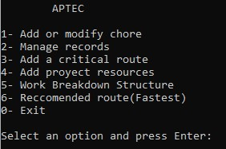

1. Exit

1. Add chores.
2. Modify chores.
3. Show chores.
4. Exit.

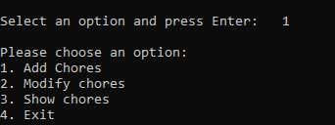

Selecting option 1 "Add Chores" prompts to enter the ID for the chore.

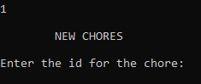

Information must be completed “Enter the ID for the chore:”, “Enter a description:”, and new options will appear.

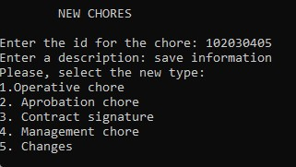

When selecting option 1 "Operative chore", it is requested to complete three questions "What is the difficulty from1 to 10?", "Please, enter the timme required for the task (in minutes)", "Who is the leader of the chores?", followed by this it asks the user do you want add more chores.

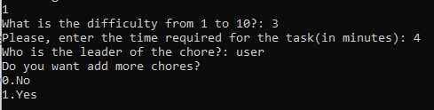

Selecting option 2 "Modify chores" will open a submenu.

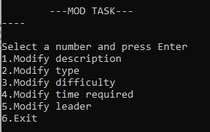

The user must complete the requested information according to the selected option.



By selecting option 3 “Show chores”, the registered tasks will appear.

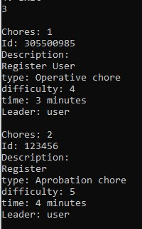

When selecting option 2 “Manage records”, the user is prompted to Enter the resource name, enter the resource type, enter resource load, enter the size of the resource and Writer the name of the leader.

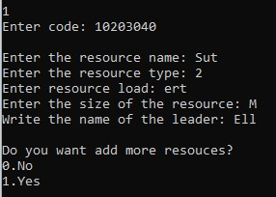

Selecting option 3 “Add a critical route” opens a submenu**.**

When selecting option 1 “New critical path”, you are requested to enter the code f the initial chore.

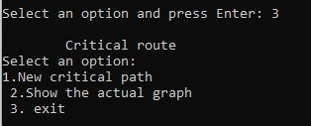

When entering option 4 “Add project resources”, it asks the user to complete the requested information.

Asks the user if they want to add more resources.

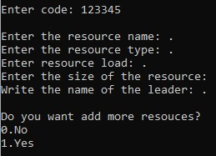

By selecting option 5 “Work Breakdown Structure”, the but of the border and weight of the registered tasks will come out.



When selecting option 6 “Recomended Route”, a new option “Recomended Route” will open, where the user enters the id of the initial chore”.

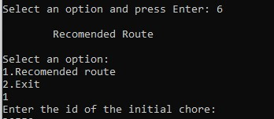

**Functionality tests.**

# Add or modify chore

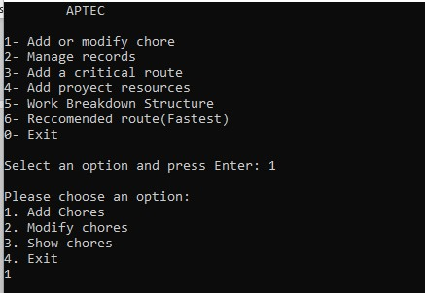

# Add chore

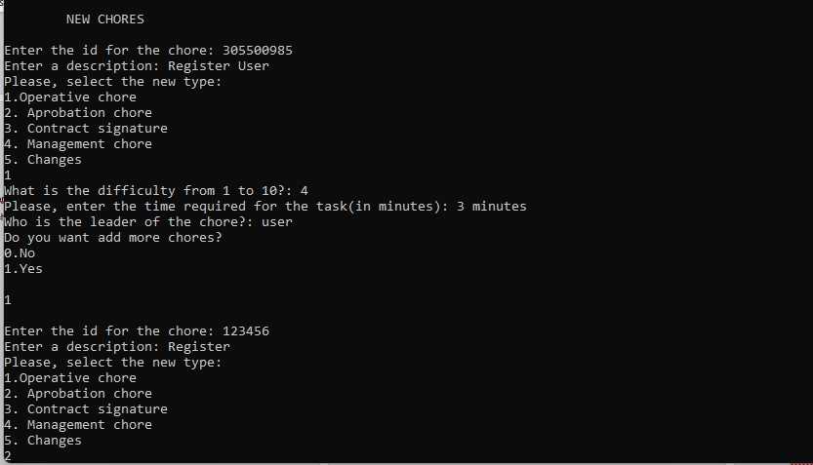

# Modify chore

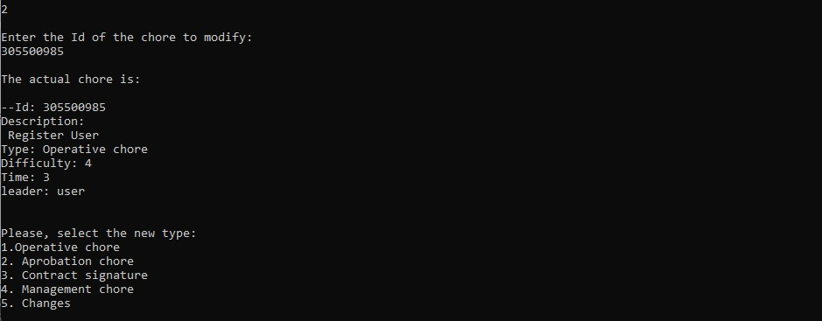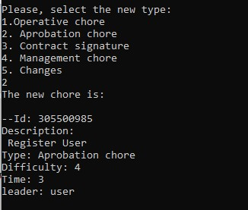

# Show chores

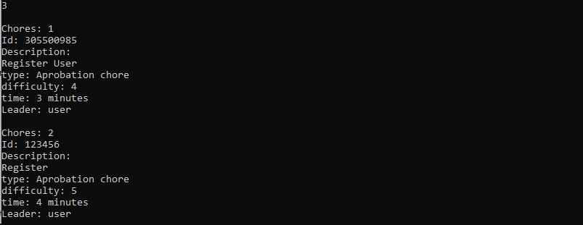

# Manage Records

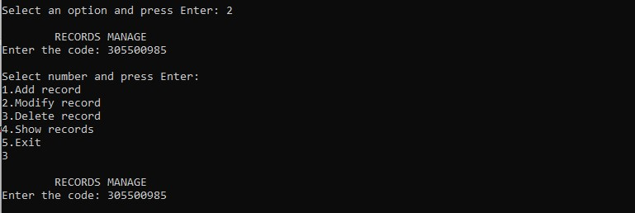

# Add a critical route New critical path

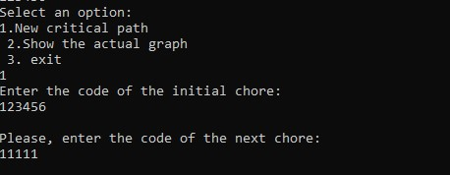

# Add proyect resources

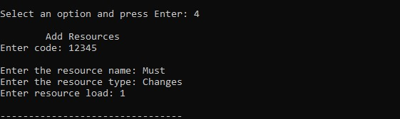

**Work Breakdown structure.**



# Reccomended route(Fastest)

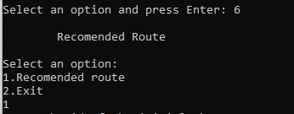

***Program design.***



**Use of Libraries.**

stdio.h library is used to include the inputs and ouputs related functions. stdlib.h library is used to work with memory allocations, process controls, etc.

string.h library is used to work with constants and declarations of several functions and types

limits.h library is used to determine various properties of different types of variables

**Use of data structures.**

Record: Is made to store the information of the documents associated with chores, called records.

Leaf: Is made to simulate the nodes of a binary tree.

Tree: Is made to simulate a binary tree.

Chores: Is made to store the information of the projects, called chores.

Resource: Is made to store the information of the resources of the chores.

Node: Is made to work with several data as nodes.

List: Is made to store data in lists

**Use of functions.**

nullMatrix: This function is used to work with different matrices.

existChores: This function is used to evaluate the existence of the different chores.

searchChores: This function is used to search for a specific chore. existRecord: This function is used to evaluate the existence of the different records. showList: This function is used to make the program display the corresponding list. printRec: This function is used to make the program print the correspondin record. showTree: This function is used to make the program display the corresponding tree.

showItemChores: This function is used to make the program display the information of the chores, called items. addChores:This function is used to add chores to work with.

addRecord: This function is used to add records to work with, necessary as they store chores information. addResource: This function is used to add resources to the different chores. modChores: This function is used to modify the information of the different chores.

addChoresMenu: This function is used to make the program display the menu to operate the addition of chores.

deleteRecordMenu: This function is used to make the program display the menu to operate the elimination of records.

modifyRecordMenu: This function is used to make the program display the menu to operate the modification of the records.

addRecordMenu: This function is used to make the program display the menu to operate the addition of records.

**Analysis of results.**

**Achieved goals:**

* Add and/or modify project tasks (Vertices of the general graph)
* Manage Task Documents (Binary Search Tree)
* Build a critical path (General graph edges)
* Project resource record (Linear Structure)
* WBS (Print the graph in the form of a minimum spanning tree)
* Recommendation of the fastest way to go between tasks by the client (Dijkstra)

**Objectives not achieved:**

**Evidence of use of Github.**



[jefferbren/PP2: Proyecto Programado 2 (github.com)](https://github.com/jefferbren/PP2)

